# logobig.pngFun2Learn

Augmented Reality Educational Games

For Kids

**By**  
  
أحمد طلب أحمد محمد  
أميرة عبد الرحيم أبو الفضل عبد اللاه  
دعاء خالد محمد على   
فاطمة مصطفى محمد فهمى مصطفى  
  
  
**Supervisor**

د/خالد فتحى حسين  
  
  
  
  
  
-2018-

**Table of contents:-**

1- **Introduction 3**

2- **Video Games 4**  
 Introduction 5  
 Definition 6  
 History 7  
 Overview 15  
 Mobile game 17  
 Game engines 19

3- **Unity 23**  
 Introduction 23  
 History 23  
 Overview 24

4- **Augmented reality 31**   
 Introduction 31  
 VR, AR and Mixed Reality 32  
 History 34  
 Overview 36

5- **Vuforia 45**  Introduction 45  
 Overview 46  
 Vuforia and Unity 48

6- **Our Game 49** Introduction 49  
 Tasks 49  
 Implementation 50  
 design 56

7- **Output 59**

**1: Introduction**

Our game is for kids learning. It is built with **Unity 3D** as a game engine and targeting **Android** platform. Using the technology of **Augmented reality**. It makes learning much easier and funnier.

This is the first phase which is concerned with alphabets and numbers in both languages Arabic and English.

In the upcoming chapters we will talk about how we built this App and also look into some of the related topics.



**2: Video Games**

Video games have been the new ascertainment for the new generation. Video games in the last decades has gained a lot of interest and traction, now we live in a decade where the video game industry is one of the richest and growing industries in the world.

In this chapter we will talk about video games and related subjects.

* **Introduction** :-

A video game is an electronic game that involves interaction with a user interface to generate visual feedback on a video device such as a TV screen or computer monitor.   
The word video in video game traditionally referred to a raster display device, but as of the 2000s, it implies any type of display device that can produce 2D or 3D images. Some theorists categorize video games as an art form, but this designation is controversial.

The electronic systems used to play video games are known as platforms; examples of these are personal computers and video game consoles. These platforms range from large mainframe computers to small handheld computing devices. Specialized video games such as arcade games, in which the video game components are housed in a large, typically coin-operated chassis, while common in the 1980s in video arcades, have gradually declined due to the widespread availability of affordable home video game consoles (e.g., PlayStation 4, Xbox One and Nintendo Wii U) and video games on desktop and laptop computers and smartphones.

The input device used for games, the game controller, varies across platforms. Common controllers include gamepads, joysticks, mouse devices, keyboards, the touchscreens of mobile devices, and buttons, or even, with the Kinect sensor, a person's hands and body. Players typically view the game on a video screen or television or computer monitor, or sometimes on virtual reality head-mounted display goggles. There are often game sound effects, music and, in the 2010s, voice actor lines which come from loudspeakers or headphones. Some games in the 2000s include haptic, vibration-creating effects, force feedback peripherals and virtual reality headsets. In the 2010s, the video game industry is of increasing commercial importance, with growth driven particularly by the emerging Asian markets and mobile games, which are played on smartphones. As of 2015, video games generated sales of USD 74 billion annually worldwide, and were the third-largest segment in the U.S. entertainment market, behind broadcast and cable TV.

Video games are a unique form of entertainment because they encourage players to become a part of the game's script. Although video games have been available for more than 30 years, today's sophisticated video games require players to pay constant attention to the game. Players engage on deeper level—physically and emotionally—than people do when watching a movie or TV.

* **Definition** :-

The term video game has evolved over the decades from a purely technical definition to a general concept defining a new class of interactive entertainment. Technically, for a product to be a video game there must be a video signal transmitted to a cathode ray tube (CRT) that creates a rasterized image on a screen. This definition would preclude early computer games that outputted results to a printer or teletype rather than a display, any game rendered on a vector-scan monitor, any game played on a modern high definition display, and most handheld game systems. From a technical standpoint, these would more properly be called "electronic games" or "computer games".

Today, however, the term "video game" has completely shed its purely technical definition and encompasses a wider range of technology. While still rather ill-defined, the term "video game" now generally encompasses any game played on hardware built with electronic logic circuits that incorporates an element of interactivity and outputs the results of the player's actions to a display. Going by this broader definition, the first video games appeared in the early 1950s and were tied largely to research projects at universities and large corporations.

* **History** :-

The history of video games goes as far back as the early 1950s, when academic computer scientists began designing simple games and simulations as part of their research. Video gaming did not reach mainstream popularity until the 1970s and 1980s, when video arcade games and gaming consoles using joysticks, buttons, and other controllers, along with graphics on computer screens and home computer games were introduced to the general public. Since the 1980s, video gaming has become a popular form of entertainment and a part of modern popular culture in most parts of the world.

One of the early games was ***Spacewar!***, which was developed by computer scientists. Early arcade video games developed from 1972 to 1978. During the 1970s, the first generation of home consoles emerged, including the popular game Pong and various "clones". The 1970s was also the era of mainframe computer games. The golden age of arcade video games was from 1978 to 1982. Video arcades with large, graphics-decorated coin-operated machines were common at malls and popular, affordable home consoles such as the Atari 2600 and Intellivision enabled people to play games on their home TVs. During the 1980s, gaming computers, early online gaming and handheld LCD games emerged; this era was affected by the video game crash of 1983. From 1976 to 1992, the second generation of video consoles emerged.

The third generation of consoles, which were 8-bit units, emerged from 1983 to 1995. The fourth generation of consoles, which were 16-bit models, emerged from 1987 to 1999. The 1990s saw the resurgence and decline of arcades, the transition to 3D video games, improved handheld games, and PC gaming. The fifth generation of consoles, which were 32 and 64-bit units, was from 1993 to 2006, during this area, mobile phone gaming emerged. During the 2000s, the sixth generation of consoles emerged (1998–2013). During this period, online gaming and mobile games became major aspects of gaming culture. The seventh generation of consoles was from 2005 to 2012. This era was marked by huge development budgets for some games, with some having cinematic graphics; the launch of the top-selling Wii console, in which the user could control the game actions with real-life movement of the controller; the rise of casual PC games marketed to non-gamers[citation needed]; and the emergence of cloud computing in video games.

In 2013, the eighth generation of consoles emerged, including Nintendo's Wii U and Nintendo 3DS, Microsoft's Xbox One, and Sony's PlayStation 4 and PlayStation Vita. PC gaming has been holding a large market share in Asia and Europe for decades and continues to grow due to digital distribution. Since the development and widespread consumer use of smartphones, mobile gaming has been a driving factor for games, as they can reach people formerly uninterested in gaming, and those unable to afford or support dedicated hardware, such as video game consoles.

* **THE EARLY DAYS**

In 1952, for instance, British professor A.S. Douglas created ***OXO***, also known as ***noughts and crosses*** or a ***tic-tac-toe***, as part of his doctoral dissertation at the University of Cambridge. And in 1958, William Higinbotham created ***Tennis for Two*** on a large analog computer and connected oscilloscope screen for the annual visitor’s day at the Brookhaven National Laboratory in Upton, New York.

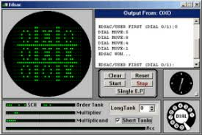 

Tennis for Two

OXO

In 1962, Steve Russell at the Massachusetts Institute of Technology invented ***Spacewar!***, a computer-based space combat video game for the PDP-1 (Programmed Data Processor-1), then a cutting-edge computer mostly found at universities. It was the first video game that could be played on multiple computer installations.

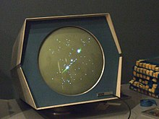

Spacewar!

* **DAWN OF THE HOME CONSOLE**

In 1967, developers at Sanders Associates, Inc., led by Ralph Baer, invented a prototype multiplayer, multi-program video game system that could be played on a television. It was known as “***The Brown Box”***.

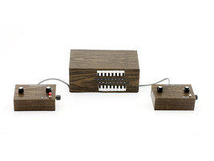

brown box

Baer, who’s sometimes referred to as Father of Video Games, licensed his device to Magnavox, which sold the system to consumers as the Odyssey, the first video game home console, in 1972. Over the next few years, the primitive Odyssey console would commercially fizzle and die out.

Yet, one of the Odyssey’s 28 games was the inspiration for Atari’s ***Pong***, the first arcade video game, which the company released in 1972. In 1975, Atari released a home version of Pong, which was as successful as its arcade counterpart.

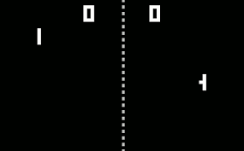

Pong

Magnavox, along with Sanders Associates, would eventually sue Atari for copyright infringement. Atari settled and became an Odyssey licensee; over the next 20 years, Magnavox went on to win more than $100 million in copyright lawsuits related to the Odyssey and its video game patents.

In 1977, Atari released the ***Atari 2600*** (also known as the Video Computer System), a home console that featured joysticks and interchangeable game cartridges that played multi-colored games, effectively kicking off the second generation of the video game consoles.

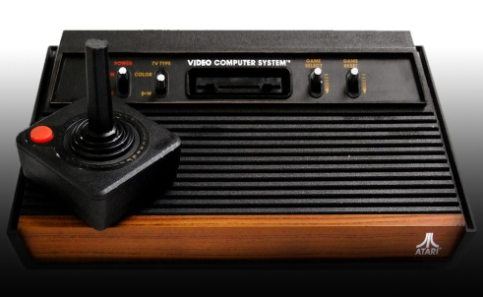

Atari 2600

The video game industry had a few notable milestones in the late 1970s and early 1980s, including:

The release of the Space Invaders arcade game in 1978

The launch of Activision, the first third-party game developer (which develops software without making consoles or arcade cabinets), in 1979

The introduction to the United States of Japan’s hugely popular Pac-Man

Nintendo’s creation of Donkey Kong, which introduced the world to the character Mario

Microsoft’s release of its first Flight Simulator game

**THE VIDEO GAME CRASH**

In 1983, the North American video game industry experienced a major “crash” due to a number of factors, including an oversaturated game console market, competition from computer gaming, and a surplus of over-hyped, low-quality games, such as the infamous E.T., an Atari game based on the eponymous movie and often considered the worst game ever created.

Lasting a couple of years, the crash led to the bankruptcy of several home computer and video game console companies.

The video game home industry began to recover in 1985 when the Nintendo Entertainment System (NES), called Famicom in Japan, came to the United States. The NES had improved 8-bit graphics, colors, sound and gameplay over previous consoles.

Nintendo, a Japanese company that began as a playing card manufacturer in 1889, released a number of important video game franchises still around today, such as ***Super Mario Bros.***, ***The Legend of Zelda***, and ***Metroid***.

Additionally, Nintendo imposed various regulations on third-party games developed for its system, helping to combat rushed, low-quality software. Third-party developers released many other long-lasting franchises, such as ***Capcom’s Mega Man, Konami’s Castlevania***, ***Square’s Final Fantasy***, and ***Enix’s Dragon Quest***.

In 1989, Nintendo made waves again by popularizing handheld gaming with the release of its 8-bit Game Boy video game device and the often-bundled game Tetris. Over the next 25 years, Nintendo would release a number of successful successors to the Game Boy, including the Game Boy color in 1998, Nintendo DS in 2004, and Nintendo 3DS in 2011.

**THE FIRST CONSOLE WAR**

Also in 1989, Sega released its 16-bit Genesis console in North America as a successor to its 1986 Sega Master System, which failed to adequately compete against the NES.

With its technological superiority to the NES, clever marketing, and the 1991 release of the ***Sonic the Hedgehog*** game, the Genesis made significant headway against its older rival. In 1991, Nintendo released its 16-bit Super NES console in North America, launching the first real “console war.”

The early- to mid-1990s saw the release of a wealth of popular games on both consoles, including new franchises such as ***Street Fighter II*** and ***Mortal Kombat***, a fighting game that depicted blood and gore on the Genesis version of the game.

In response to the violent game (as well as congressional hearings about violent video games), Sega created the Videogame Rating Council in 1993 to provide descriptive labeling for every game sold on a Sega home console. The council later gives rise to the industry-wide Entertainment Software Rating Board, which is still used today to rate video games based on content.

In the mid-1990s, video games leaped to the Big Screen with the release of the ***Super Mario Bros***. live-action movie in 1993, followed by ***Street Fighter*** and ***Mortal Kombat*** over the next two years. Numerous movies based on video games have been released since.

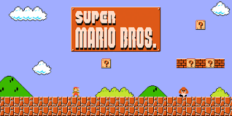

Super Mario Bros

With a much larger library of games, lower price point, and successful marketing, the Genesis had leapfrogged ahead of the SNES in North America by this time. But Sega was unable to find similar success in Japan.

**THE RISE OF 3D GAMING**

With a leap in computer technology, the fifth generation of video games ushered in the three-dimensional era of gaming.

In 1995, Sega released in North America its Saturn system, the first 32-bit console that played games on CDs rather than cartridges, five months ahead of schedule. This move was to beat Sony’s first foray into video games, the PlayStation, which sold for $100 less than the Saturn when it launched later that year. The following year, Nintendo released its cartridge-based 64-bit system, the Nintendo 64.

Though Sega and Nintendo each released their fair share of highly-rated, on-brand 3D titles, such as ***Virtua Fighter*** on the Saturn and ***Super Mario 64*** on the Nintendo 64, the established video game companies couldn’t compete with Sony’s strong third-party support, which helped the PlayStation secure numerous exclusive titles.

Simply put: Sony dominated the video game market and would continue to do so into the next generation. In fact, the PlayStation 2, released in 2000 and able to play original PlayStation games, would become the best-selling game console of all time.

The PlayStation 2, which was the first console that used DVDs, went up against the Sega Dreamcast (released in 1999), the Nintendo Gamecube (2001), and Microsoft’s Xbox (2001).

The Dreamcast—considered by many to be ahead of its time and one of the greatest consoles ever made for several reasons, including its capability for online gaming—was a commercial flop that ended Sega’s console efforts. Sega pulled the plug on the system in 2001, becoming a third-party software company henceforth.

**MODERN AGE OF GAMING**

In 2005 and 2006, Microsoft’s Xbox 360, Sony’s PlayStation 3, and Nintendo’s Wii kicked off the modern age of high-definition gaming. Though the PlayStation 3—the only system at the time to play Blu-rays—was successful in its own right, Sony, for the first time, faced stiff competition from its rivals.

The Xbox 360, which had similar graphics capabilities to the PlayStation 3, was lauded for its online gaming ecosystem and won far more Game Critics Awards than the other platforms in 2007; it also featured the Microsoft Kinect, a state-of-the-art motion capture system that offered a different way to play video games (though the Kinect never caught on with core gamers or game developers).

And despite being technologically inferior to the other two systems, the Wii trounced its competition in sales. Its motion-sensitive remotes made gaming more active than ever before, helping it appeal to a much larger slice of the general public, including people in retirement homes.

Towards the end of the decade and beginning of the next, video games spread to social media platforms like Facebook and mobile devices like the iPhone, reaching a more casual gaming audience. Rovio, the company behind the ***Angry Birds*** mobile device game (and, later Angry Birds animated movie), reportedly made a whopping $200 million in 2012.

In 2011, Skylanders: Spyro’s Adventure brought video games into the physical world. The game required players to place plastic toy figures (sold separately) onto an accessory, which reads the toys’ NFC tags to bring the characters into the game. The next few years would see several sequels and other toy-video game hybrids, such as ***Disney Infinity***, which features Disney characters.

The 8th and current generation of video games began with the release of Nintendo’s Wii U in 2012, followed by the PlayStation 4 and Xbox One in 2013. Despite featuring a touch screen remote control that allowed off-TV gaming and being able to play ***Wii*** games, the ***Wii U*** was a commercial failure—the opposite of its competition—and was discontinued in 2017.

In 2016, Sony released a more powerful version of its console, called the PlayStation 4 Pro, the first console capable of 4 K video outputs. In early 2017, Nintendo released its Wii U successor, the Nintendo Switch, the only system to allow both television-based and handheld gaming. Microsoft will release its 4K-ready console, the Xbox One X, in late 2017.

With their new revamped consoles, both Sony and Microsoft currently have their sights set on virtual reality gaming, a technology that has the potential to change the way players experience video games.

* **Overview** :-

**Platforms**

The term "platform" refers to the specific combination of electronic components or computer hardware which, in conjunction with software, allows a video game to operate. The term "system" is also commonly used. there may be games that bridge one or more platforms. In addition to personal computers, there are other devices which have the ability to play games but are not dedicated video game machines, such as smartphones, PDAs and graphing calculators.

* **PC**

In common use a "PC game" refers to a form of media that involves a player interacting with a personal computer connected to a video monitor. Personal computers are not dedicated game platforms, so there may be differences running the same game in different hardware, also the openness allows some features to developers like reduced software cost, increased flexibility, increased innovation, emulation, creation of modifications ("mods"), open hosting for online gaming (in which a person plays a video game with people who are in a different household) and others.

* **Console**

A "console game" is played on a specialized electronic device that connects to a common television set or composite video monitor, unlike PCs, which can run all sorts of computer programs, a console is a dedicated video game platform manufactured by a specific company. Usually consoles only run games developed for it, or games from other platform made by the same company, but never games developed by its direct competitor, even if the same game is available on different platforms. It often comes with a specific game controller. Major console platforms include Xbox, PlayStation, and Nintendo.

* **Handheld**

A "handheld" gaming device is a small, self-contained electronic device that is portable and can be held in a user's hands. It features the console, a small screen, speakers and buttons, joystick or other game controllers in a single unit. Like consoles, handhelds are dedicated platforms, and share almost the same characteristics. Handheld hardware usually is less powerful than PC or console hardware. Some handheld games from the late 1970s and early 1980s could only play one game. In the 1990s and 2000s, a number of handheld games used cartridges, which enabled them to be used to play many different games.

* **Arcade**

"Arcade game" generally refers to a game played on an even more specialized type of electronic device that is typically designed to play only one game and is encased in a special, large coin-operated cabinet which has one built-in console, controllers (joystick, buttons, etc.), a CRT screen, and audio amplifier and speakers. Arcade games often have brightly painted logos and images relating to the theme of the game. While most arcade games are housed in a vertical cabinet, which the user typically stands in front of to play, some arcade games use a tabletop approach, in which the display screen is housed in a table-style cabinet with a see-through table top. With table-top games, the users typically sit to play. In the 1990s and 2000s, some arcade games offered players a choice of multiple games. In the 1980s, video arcades were businesses in which game players could use a number of arcade video games. In the 2010s, there are far fewer video arcades, but some movie theaters and family entertainment centers still have them

* **Web browser**

The web browser has also established itself as platform in its own right in the 2000s, while providing a cross-platform environment for video games designed to be played on a wide spectrum of hardware from personal computers and tablet computers to smartphones. This in turn has generated new terms to qualify classes of web browser-based games. These games may be identified based on the website that they appear, such as with "Facebook" games. Others are named based on the programming platform used to develop them, such as Java and Flash games.

* **Mobile**

With the advent of standard operating systems for mobile devices such as iOS and Android and devices with greater hardware performance, mobile gaming has become a significant platform. While many mobile games share similar concepts with browser games, these games may utilize features of smart devices that are not necessary present on other platforms such as global positing information and camera devices to support augmented reality gameplay. Mobile games also led into the development of microtransactions as a valid revenue model for casual games.

* **Virtual reality**

Virtual reality (VR) games generally require players to use a special head-mounted unit that provides stereoscopic screens and motion tracking to immerse a player within virtual environment that responds to their head movements. Some VR systems include control units for the player's hands as to provide a direct way to interact with the virtual world. VR systems generally require a separate computer, console, or other processing device that couples with the head-mounted unit.

* **Blockchain**

A new platform of video games emerged in late 2017 in which users could take ownership of game assets (digital assets) using Blockchain technologies. An example of this is Cryptokitties.

* **Mobile game :-**

A mobile game is a video game played on a feature phone, smartphone/tablet, smartwatch, PDA, portable media player or graphing calculator.

The earliest known game on a mobile phone was a Tetris variant on the Hagenuk MT-2000 device from 1994.

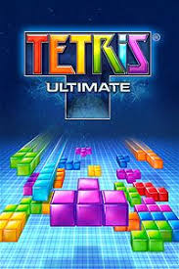

In 1997, Nokia launched the very successful Snake. Snake (and its variants), that was preinstalled in most mobile devices manufactured by Nokia, has since become one of the most played video games and is found on more than 350 million devices worldwide. A variant of the Snake game for the Nokia 6110, using the infrared port, was also the first two-player game for mobile phones.

Today, mobile games are usually downloaded from app stores as well as from mobile operator's portals, but in some cases are also preloaded in the handheld devices by the OEM or by the mobile operator when purchased, via infrared connection, Bluetooth, memory card or side loaded onto the handset with a cable.

Downloadable mobile games were first commercialised in Japan circa the launch of NTT DoCoMo's I-mode platform in 1999, and by the early 2000s were available through a variety of platforms throughout Asia, Europe, North America and ultimately most territories where modern carrier networks and handsets were available by the mid-2000s. However, mobile games distributed by mobile operators and third party portals (channels initially developed to monetise downloadable ringtones, wallpapers and other small pieces of content using premium SMS or direct carrier charges as a billing mechanism) remained a marginal form of gaming until Apple's iOS App Store was launched in 2008. As the first mobile content marketplace operated directly by a mobile platform holder, the App Store significantly changed the consumer behaviour and quickly broadened the market for mobile games, as almost every smartphone owner started to download mobile apps.

Mobile games have been developed to run on a wide variety of platforms and technologies. These include the (today largely defunct) Palm OS, Symbian, Adobe Flash Lite, NTT DoCoMo's DoJa, Sun's Java, Qualcomm's BREW, WIPI, BlackBerry, Nook and early incarnations of Windows Mobile. Today, the most widely supported platforms are Apple's iOS and Google's Android. The mobile version of Microsoft's Windows 10 (formerly Windows Phone) is also actively supported, although in terms of market share remains marginal compared to iOS and Android.

Java was at one time the most common platform for mobile games, however its performance limits lead to the adoption of various native binary formats for more sophisticated games.

Due to its ease of porting between mobile operating systems and extensive developer community, Unity is one of the most widely used engines used by modern mobile games. Apple provide a number of proprietary technologies (such as Metal) intended to allow developers to make more effective use of their hardware in iOS-native games.

Typically, commercial mobile games use one of the following monetisation models: pay-per-download, subscription, free-to-play ('freemium') or advertising-supported. Until recently, the main option for generating revenues was a simple payment on downloading a game. Subscription business models also existed and had proven popular in some markets (notably Japan) but were rare in Europe. Today, a number of new business models have emerged which are often collectively referred to as "freemium". The game download itself is typically free and then revenue is generated after download either through in-app transactions or advertisements; this resulted in $34 billion spent on mobile games in 2013.

* **Game engines :-**

A game engine is a software framework designed for the creation and development of video games. Developers use them to create games for consoles, mobile devices, and personal computers. The core functionality typically provided by a game engine includes a rendering engine ("renderer") for 2D or 3D graphics, a physics engine or collision detection (and collision response), sound, scripting, animation, artificial intelligence, networking, streaming, memory management, threading, localization support, scene graph, and may include video support for cinematics. The process of game development is often economized, in large part, by reusing/adapting the same game engine to create different games or to make it easier to port games to multiple platforms.

* **Components**
* **Main game program**

The actual game logic has to be implemented by some algorithms. It is distinct from any rendering, sound or input work.

* **Rendering engine**

The rendering engine generates 3D animated graphics by the chosen method (rasterization, ray-tracing or any different technique).

Instead of being programmed and compiled to be executed on the CPU or GPU directly, most often rendering engines are built upon one or multiple rendering application programming interfaces (APIs), such as Direct3D or OpenGL which provide a software abstraction of the graphics processing unit (GPU).

Low-level libraries such as DirectX, Simple DirectMedia Layer (SDL), and OpenGL are also commonly used in games as they provide hardware-independent access to other computer hardware such as input devices (mouse, keyboard, and joystick), network cards, and sound cards. Before hardware-accelerated 3D graphics, software renderers had been used. Software rendering is still used in some modeling tools or for still-rendered images when visual accuracy is valued over real-time performance (frames-per-second) or when the computer hardware does not meet needs such as shader support.

With the advent of hardware accelerated physics processing, various physics APIs such as PAL and the physics extensions of COLLADA became available to provide a software abstraction of the physics processing unit of different middleware providers and console platforms.

Game engines can be written in any programming language like C++, C or Java, though each language is structurally different and may provide different levels of access to specific functions.

* **Audio engine**

The audio engine is the component which consists of algorithms related to sound. It can calculate things on the CPU, or on a dedicated ASIC. Abstraction APIs, such as OpenAL, SDL audio, XAudio 2, Web Audio, etc. are available.

* **Physics engine**

The physics engine is responsible for emulating the laws of physics realistically within the application.

* **Artificial intelligence**

The AI is usually outsourced from the main game program into a special module to be designed and written by software engineers with specialist knowledge.

* **List of popular game engines:**

|  |  |  |  |  |
| --- | --- | --- | --- | --- |
| **Engine** | **Programming required?** | **2D / 3D** | **Available for** | **Exports to** |
| Construct 2 | No | 2D (All Genres) | Windows | Desktop, Consoles, Mobile, Web |
| GameMaker: Studio | No | 2D (All Genres) | Windows | Desktop, Consoles, Mobile, Web |
| Unity | Yes | 2D + 3D (All Genres) | Windows, Mac | Desktop, Consoles, Mobile, Web |
| Unreal Engine | Yes | 3D (All Genres) | Windows, Mac | Desktop, Consoles, Mobile |
| Clickteam Fusion | No | 2D (All Genres) | Windows | Desktop, Mobile, Web |
| Stencyl | No | 2D (All Genres) | Windows, Mac, Linux | Desktop, Mobile, Web |
| GameSalad | No | 2D (All Genres) | Windows, Mac | Desktop, Mobile, Web |

**3: Unity**

Our game is built using unity game engine; in this chapter we will talk about unity.



* **Introduction :-**

Unity is a multipurpose game engine that supports 2D and 3D graphics, drag-and-drop functionality and [scripting](https://en.wikipedia.org/wiki/Scripting_language) using [C#](https://en.wikipedia.org/wiki/C_Sharp_(programming_language)). Two other programming languages were supported: [Boo](https://en.wikipedia.org/wiki/Boo_(programming_language)), and JavaScript.

Unity is a [cross-platform](https://en.wikipedia.org/wiki/Cross-platform) [game engine](https://en.wikipedia.org/wiki/Game_engine) developed by [Unity Technologies](https://en.wikipedia.org/wiki/Unity_Technologies) for creating beautiful and engaging 2D, 3D, VR, and AR games and apps. A powerful graphics engine and full-featured editor enable you to realize your creative vision fast, and deliver your content to virtually any media or device. You can easily connect to your audiences on PCs, consoles, the web, mobile devices, home entertainment systems, embedded systems, or head-mounted displays.

Unity also offers services to developers include the Unity Asset Store, Unity Ads, Unity Analytics, Unity Certification, Unity Cloud Build, Unity Everyplay, Unity IAP, Unity Multiplayer, Unity Performance Reporting and Unity Collaborate.

* **History :-**

In 2012, VentureBeat said, "Few companies have contributed as much to the flowing of independently produced games as Unity Technologies. ... More than 1.3 million developers are using its tools to create gee-whiz graphics in their iOS, Android, console, PC, and web-based games. ... Unity wants to be the engine for multi-platform games, period."

For the Apple Design Awards at the 2006 WWDC trade show, Apple, Inc. named Unity as the runner-up for its Best Use of Mac OS X Graphics category, a year after Unity's launch at the same trade show. Unity Technologies says this is the first time a game design tool has ever been nominated for this award. A May 2012 survey by Game Developer magazine indicated Unity as its top game engine for mobile platforms. In July 2014, Unity won the "Best Engine" award at the UK's annual Develop Industry Excellence Awards.

Unity 5 was met with similar praise, with The Verge stating that "Unity started with the goal of making game development universally accessible.... Unity 5 is a long-awaited step towards that future".

Following the release of Unity 5, Unity Technologies drew some criticism for the high volume of quickly produced games published on the Steam distribution platform by inexperienced developers. CEO John Riccitiello said in an interview that he believes this to be a side-effect of Unity's success in democratizing game development: "If I had my way, I'd like to see 50 million people using Unity – although I don't think we're going to get there any time soon. I'd like to see high school and college kids using it, people outside the core industry. I think it's sad that most people are consumers of technology and not creators. The world's a better place when people know how to create, not just consume, and that's what we're trying to promote".

In December 2016, Unity Technologies announced that they will change the versioning numbering system for Unity from sequence-based identifiers to year of release to align the versioning with their more frequent release cadence.

* **Overview :-**
* Versions

**1.** Unity 1.x

Unity 1.0 was announced at the Apple Worldwide Developers Conference in 2005 and was released on June 8, 2005. The initial release was limited to Mac OS, both for authoring and game publishing. Features at the time included a shader-oriented OpenGL renderer, physics powered by the Novodex (now PhysX) physics engine, audio support and C# scripting support. The package was available in both a low-priced 'Indie' edition, and a higher-priced 'Pro' edition which included some extra features.

Over subsequent 1.x versions, significant additions included support for building games to run on Windows, both as standalone applications and also in browsers via a browser plugin.

**2.** Unity 2.x

Unity 2.0 was released on October 11, 2007, during the first annual Unite conference. Key additions to the feature set included a terrain engine, networking system (based on RakNet), real-time dynamic shadow rendering, and a system for building game UI. This release also saw the introduction of Unity Asset Server, an add-on product intended to allow teams of developers to share project assets more easily.

On October 4, 2008, the iPhone publishing add-on was announced. This allowed developers to author their games on Mac and publish to iPhone.

In Unity 2.5, released March 19, 2009, support for authoring games on Windows was released.

At the October 2009 Unite conference, it was announced that Unity Technologies would no longer charge for the 'indie' edition of Unity, but would instead make it freely available.

**3.** Unity 3.x

Unity 3.0 was released on October 4, 2010. This brought integrated light mapping support using Illuminate Labs' Beast technology, occlusion culling powered by Umbra, real-time audio processing effects, and support for C# 3.5. The release also included a 'preview quality' release of support for Android game publishing, sold as a separate add-on; Android support was officially declared 'released' on March 1, 2011.

On November 10, 2010, the Unity Asset Store was launched as an online marketplace for Unity users to sell project assets - artwork, code systems, audio, etc. - to each other.

Unity 3.4 introduced integrated support for Allegorithmic's "Substance" procedural material system.

Unity 3.5, released February 14, 2012, was a notable release for bringing several new features quite late in the version lifecycle: a new particle system named "Shuriken," an integrated pathfinding and navigation framework, level-of-detail management for 3D models, high-dynamic-range rendering, new global illumination features, and a rewrite of the occlusion culling support. This release also saw the introduction of preview support for both Adobe Flash and Google Native Client as publishing platforms.

**4.** Unity 4.x

Unity 4.0 was officially released on November 13, 2012. Major new features include new 'Mecanim' animation system, DirectX 11 support, Linux publishing support and real-time shadows on mobile platforms.

With the release of Unity 4.0, the company announced a shift towards a release cycle which would see versions be released with fewer features but at a faster rate. As such, subsequent releases in the 4.X line delivered new features as follows:

Unity 4.1, released March 13, 2013: Memory profiling, support for AirPlay on iOS, and a slew of smaller feature updates for Mecanim and shader editing.

Unity 4.2, released July 22, 2013: Support for Windows Phone 8, Windows Store and BlackBerry as publishing platforms; OpenGL ES 3.0 support for mobile platforms; integrated version control support for Perforce; and the ability to cancel the build process once started. (The last of these got a round of applause when it was announced at 2013's Unite Nordic).

Unity 4.3, released November 12, 2013: a new 2D framework, including both 2D rendering support and a 2D physics engine (powered by Box2D).

Unity 4.5, released May 27, 2014: no significant new features were introduced, as instead this release focused on fixing bugs, reporting more than 450 fixes in the release.

Unity 4.6, released November 26, 2014: a new UI Framework. Also, version 4.6.2, released on January 29, 2015, added support for 64-bit applications on iOS.

On May 21, 2013, CEO David Helgason announced that the 'basic' editions of the iPhone and Android mobile add-ons would now be available for free from Unity 4.2 onwards.

**5.** Unity 5.x

Unity 5.0 was released for free on March 3, 2015, adding the much anticipated real-time global illumination based on the Geomerics Enlighten technology. Other major changes include physically-based shaders, HDR sky-boxes, reflection probes, a new audio mixer with effects and enhanced animator workflows.

Unity's Cloud Build system was introduced (for $25/month for non-pro users) as well as 'Game Performance Reporting' and the beta 'Game Analytics' (also $25/month for non-pro users) which logs players usage and performance on released games, something that many developers found hard to implement in Unity 4.x. Previously, a game developer needed to code support for player logging directly into their game engine.

Smaller additions include: A 64-bit editor to handle large projects, iOS 64-bit support, new deferred rendering, graphics command buffers, improved linear lighting, HDR, skybox and cubemap workflows, improved job scheduling system, a new 'CPU Timeline Profiler' lets you see and investigate multicore usage, improved NavMesh pathfinding system, intth.

Up until Unity 5.0 the engine was using a fairly outdated version of Nvidia's PhysX physics middleware. The 3.3 version included in Unity 5.0 which is standard among triple-n Unity.

Unity 5.0 brings support for Windows, OS X, Linux, Unity Webplayer, Android, iOS, BlackBerry 10, Windows Phone 8, Tizen, WebGL, PlayStation 3, PlayStation 4, PlayStation Vita, Wii U, New 3DS, Xbox 360, Xbox One, Android TV, Samsung Smart TV, Oculus Rift and Gear VR for a total of 21 supported platforms.

**6.** Unity 2017.x

The Unity 4.7.1 adds Xcode 7.3 support for iOS and includes a couple of other fixes. This release marks the debut of the new Unity 2017 cycle, evolving the world’s most popular game engine into an ever-expanding creation engine for gaming and real-time entertainment, with a strong focus on helping teams work better and enabling success.

Unity 2017.1 includes a ton of new features and improvements. introduces new ways artists & designers can create stunning cinematic content, compose artistic camera shots and tell better visual stories with the Timeline, Cinemachine and Post-processing tools.

Timeline is a powerful new visual tool that allows you to create cinematic content such as cutscenes and trailers, gameplay sequences, and much more.

Cinemachine is an advanced camera system that enables you to compose your shots like a movie director from within Unity, without any code, and ushers in the era of procedural cinematography.

Post-processing lets you easily apply realistic filters to scenes using film industry terminology, controls, and color space formats to create high quality visuals for more dramatic and realistic looks, so you can tell a better visual story.

Efficiency: collaboration, live-ops analytics, tools

On top of that, there are many productivity updates to the Editor, including improvements to FBX import, animation workflows, 2D functionality, working with assets bundles and Visual Studio integration.

Graphics & Platforms: improvements across the board

There are a number of advancements in the areas of Particle Systems and the Progressive Lightmapper offering more options to achieve your artistic vision and control performance. Various platforms get rendering boost options with Deferred Rendering on iOS and NVIDIA VRWorks on PC.

* Games using unity

|  |  |  |  |
| --- | --- | --- | --- |
| **Release date** | **Title** | **Genre** | **Platform** |
| 2005-03 | [GooBall](https://en.wikipedia.org/wiki/GooBall) | Action | [Mac OS X](https://en.wikipedia.org/wiki/Mac_OS_X) |
| 2008-04-21 | Dead Frontier | Survival horror, massively multiplayer online game | Microsoft Windows |
| 2008-01-29 | Off-Road Velociraptor Safari | Vehicular combat | Mac OS X, Microsoft Windows |
| 2009-11-16 | Three Kingdoms Online | MMORPG, Browser game | Browser game |
| 2009-01-14 | Cartoon Network Universe: FusionFall | MMORPG, Third Person Shooter | Mac OS X, Microsoft Windows |
| 2010-01-22 | Max & the Magic Marker | Platformer | Mac OS X, Wii (WiiWare), Microsoft Windows, Windows Phone, iOS, PlayStation Network, Nintendo DS[1] |
| 2010-05-26 | Fractal | Puzzle, Strategy | Mac OS X, Microsoft Windows, Linux, iOS, Android |
| 2011-02-08 | Battlestar Galactica Online | MMO, Browser game | Browser game |
| 2011-03-21 | I Am Playr | Sports game | Browser game |
| 2012-06-26 | Slender: The Eight Pages | Survival horror | Mac OS X, Microsoft Windows |
| 2012-08-27 | The World Ends With You: Solo Remix | Action role-playing | iOS, Android |
| 2013-01-16 | Temple Run 2 | Endless runner | iOS, Android, Windows Phone 8 |
| 2013-02-22 | The Bridge | Puzzle video game | Microsoft Windows, Linux, Xbox 360, Xbox One, Android, Ouya, PlayStation 3, PlayStation 4, PlayStation Vita, Wii U |
| 2014-6-12 | Angry Birds Epic | Role-playing | Android, iOS,  Windows Phone,BlackBerry 10 |
| 2014-5-7 | Tesla Effect: A Tex Murphy Adventure | Adventure | Microsoft Windows, OS X |
| 2015-4-2 | War for the Overworld | Real-time strategy, god game, dungeon management game | Windows, OS X, Linux |
| 2015-7-30 | Angry Birds 2 | Puzzle | iOS, Android |
| 2016-7-6 | Pokémon Go | Augmented reality, location-based game | iOS, Android |
| 2017-11-21 | Animal Crossing: Pocket Camp | Social simulation | iOS, Android |

**4- Augmented Reality :-**

Our game is developed using the technology of augmented reality.

In this chapter we will talk about augmented reality and related topics.

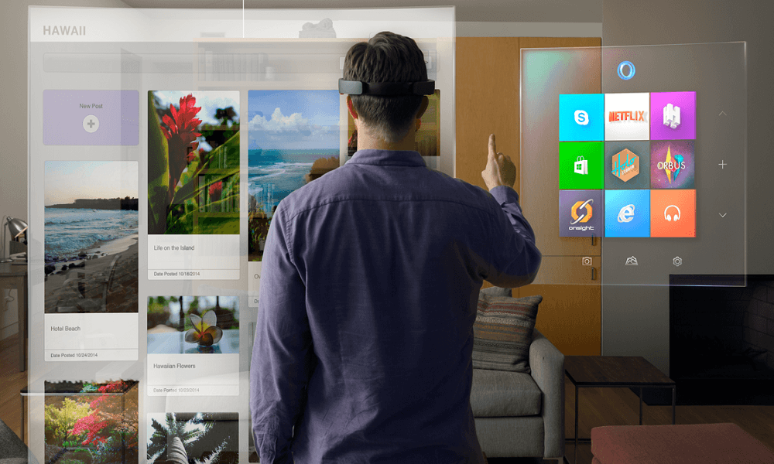

* **Introduction :-**

Augmented Reality is an enhanced version of reality where live direct or indirect views of physical real-world environments are augmented with superimposed computer-generated images over a user's view of the real-world, thus enhancing one’s current perception of reality.

The origin of the word augmented is augment, which means to add or enhance something. In the case of Augmented Reality (also called AR), graphics, sounds, and touch feedback are added into our natural world to create an enhanced user experience.

Augmented reality has come a long way from a science-fiction concept to a science-based reality. Until recently the costs of augmented reality were so substantial that designers could only dream of working on design projects that involved it – today things have changed and augmented reality is even available on the mobile handset. That means design for augmented reality is now an option for all shapes and sizes of UX designers.

Augmented reality is a view of the real, physical world in which elements are enhanced by computer-generated input. These inputs may range from sound to video, to graphics to GPS overlays and more. The first conception of augmented reality occurred in a novel by Frank L Baum written in 1901 in which a set of electronic glasses mapped data onto people; it was called a “character marker”. Today, augmented reality is a real thing and not a science-fiction concept.

* **VR, AR and Mixed Reality :-**
* Virtual Reality (VR) :-

This technology immerses users in a completely virtual environment that is generated by a computer. The most advanced VR experiences even provide freedom of movement users can move in a digital environment and hear sounds. Moreover, special hand controllers can be used to enhance VR experiences.

You need to wear a special VR headset to experience virtual reality. Most VR headsets are connected to a computer (Oculus Rift) or a gaming console (PlayStation VR) but there are standalone devices (Google Cardboard is among the most popular) as well. Most standalone VR headsets work in combination with smartphones – you insert a smartphone, wear a headset, and immerse in the virtual reality.

* Augmented Reality

In augmented reality, users see and interact with the real world while digital content is added to it. If this sounds unclear think of ***Pokemon Go*** millions of people all over the world have been rushing with their smartphones in search for small virtual creatures. That’s the most vivid example of augmented reality.

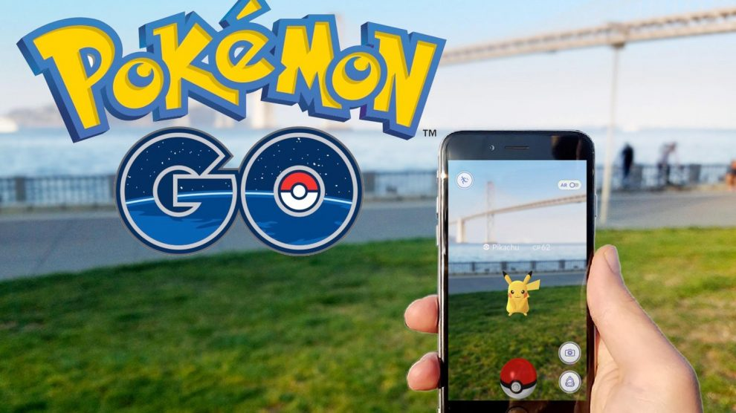

Pokemon Go

If you own a modern smartphone, you can easily download an AR app and try this technology. There’s a different way to experience augmented reality, though – with special AR headsets, such as Google Glass, where digital content is displayed on a tiny screen in front of a user’s eye.

* Mixed Reality

This is the most recent development in reality technologies that sometimes causes confusion, primarily because different experiences are called so. Without going too deep into science, Here's two forms of reality technologies that are referred to as mixed reality :-

* Mixed reality that starts with the real world – virtual objects are not just overlaid on the real world but can interact with it. In this case, a user remains in the real-world environment while digital content is added to it; moreover, a user can interact with virtual objects. This form of mixed reality can be considered an advanced form of AR. If you can’t figure out how this works, take a look at how Skype is used on Microsoft HoloLens.
* Mixed reality that starts with the virtual world – the digital environment is anchored to and replaces the real world. In this case, a user is fully immersed in the virtual environment while the real world is blocked out. Sounds like virtual reality, right? In fact it does, but the digital objects overlap the real ones whereas in conventional VR the virtual environment isn’t connected to the real world around a user. To experience this form of mixed reality, you can wear Windows mixed reality headsets. Here’s an example of how it all works.
* **History :-**

Augmented reality was first achieved, to some extent, by a cinematographer called Morton Heilig in 1957. He invented the ***Sensorama*** which delivered visuals, sounds, vibration and smell to the viewer. Of course, it wasn’t computer controlled but it was the first example of an attempt at adding additional data to an experience.

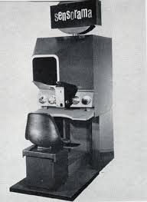

Sensorama

Then in 1968, Ivan Sutherland the American computer scientist and early Internet influence, invented the ***head-mounted display*** as a kind of window into a virtual world. The technology used at the time made the invention impractical for mass use.

In 1975, Myron Krueger, an American computer artist developed the first “virtual reality” interface in the form of “Videoplace” which allowed its users to manipulate and interact with virtual objects and to do so in real-time.

Steve Mann, a computational photography researcher, gave the world wearable computing in 1980.

Of course back then these weren’t “virtual reality” or “augmented reality” because virtual reality was coined by Jaron Lainer in 1989 and Thomas P Caudell of Boeing coined the phrase “augmented reality” in 1990.



head-mounted display

The first properly functioning AR system was probably the one developed at USAF Armstrong’s Research Lab by Louis Rosenberg in 1992. This was called Virtual Fixtures and was an incredibly complex robotic system which was designed to compensate for the lack of high-speed 3D graphics processing power in the early 90s. It enabled the overlay of sensory information on a workspace to improve human productivity

There were many other breakthroughs in augmented reality between here and today; the most notable of which include:

* Bruce Thomas developing an outdoor mobile AR game called ARQuake in 2000.
* ARToolkit (a design tool) being made available in Adobe Flash in 2009.
* Google announcing its open beta of Google Glass (a project with mixed successes) in 2013.
* Microsoft announcing augmented reality support and their augmented reality headset HoloLens in 2015
* **Overview :-**
* Categories :

Several categories of augmented reality technology exist, each with varying differences in their objectives and application use cases. Below, we explore the various types of technologies that make up augmented reality:

* Marker Based Augmented Reality

Marker-based augmented reality (also called Image Recognition) uses a camera and some type of visual marker, such as a QR/2D code, to produce a result only when the marker is sensed by a reader. Marker based applications use a camera on the device to distinguish a *marker* from any other real world object. Distinct, but simple patterns (such as a QR Code) are used as the markers, because they can be easily recognized and do not require a lot of processing power to read. The position and orientation is also calculated, in which some type of content and/or information is then overlaid the marker.

* Markerless Augmented Reality

As one of the most widely implemented applications of augmented reality, markerless (also called location-based, position-based, or GPS) augmented reality, uses a GPS, digital compass, velocity meter, or accelerometer which is embedded in the device to provide data based on your location. A strong force behind markerless augmented reality technology is the wide availability of smartphones and location detection features they provide. It is most commonly used for mapping directions, finding nearby businesses, and other location-centric mobile applications.

* Projection Based Augmented Reality

Projection based augmented reality works by projecting artificial light onto real world surfaces. Projection based augmented reality applications allow for human interaction by sending light onto a real world surface and then sensing the human interaction (i.e. touch) of that projected light. Detecting the user’s interaction is done by differentiating between an expected (or known) projection and the altered projection (caused by the user's interaction). Another interesting application of projection based augmented reality utilizes laser plasma technology to project a three-dimensional (3D) interactive hologram into mid-air.

* Superimposition Based Augmented Reality

Superimposition based augmented reality either partially or fully replaces the original view of an object with a newly augmented view of that same object.

In superimposition based augmented reality, object recognition plays a vital role because the application cannot replace the original view with an augmented one if it cannot determine what the object is. A strong consumer-facing example of superimposition based augmented reality could be found in the Ikea augmented reality furniture catalogue. By downloading an app and scanning selected pages in their printed or digital catalogue, users can place virtual ikea furniture in their own home with the help of augmented reality.

* Technology
* Hardware

Hardware components for augmented reality are: processor, display, sensors and input devices. Modern mobile computing devices like smartphones and tablet computers contain these elements which often include a camera and MEMS sensors such as accelerometer, GPS, and solid state compass, making them suitable AR platforms.

* Software and algorithms

A key measure of AR systems is how realistically they integrate augmentations with the real world. The software must derive real world coordinates, independent from the camera, from camera images. That process is called image registration, and uses different methods of computer vision, mostly related to video tracking.[72][73] Many computer vision methods of augmented reality are inherited from visual odometry.

Usually those methods consist of two parts. The first stage is to detect interest points, fiducial markers or optical flow in the camera images. This step can use feature detection methods like corner detection, blob detection, edge detection or thresholding, and other image processing methods.[74][75] The second stage restores a real world coordinate system from the data obtained in the first stage. Some methods assume objects with known geometry (or fiducial markers) are present in the scene. In some of those cases the scene 3D structure should be precalculated beforehand. If part of the scene is unknown simultaneous localization and mapping (SLAM) can map relative positions. If no information about scene geometry is available, structure from motion methods like bundle adjustment are used. Mathematical methods used in the second stage include projective (epipolar) geometry, geometric algebra, rotation representation with exponential map, kalman and particle filters, nonlinear optimization, robust statistics.[citation needed]

Augmented Reality Markup Language (ARML) is a data standard developed within the Open Geospatial Consortium (OGC), which consists of XML grammar to describe the location and appearance of virtual objects in the scene, as well as ECMAScript bindings to allow dynamic access to properties of virtual objects.

To enable rapid development of augmented reality applications, some software development kits (SDKs) have emerged.[77][78] A few SDKs such as CloudRidAR leverage cloud computing for performance improvement. AR SDKs are offered by Vuforia, ARToolKit, Catchoom CraftAR Mobinett AR, Wikitude, Blippar Layar, Meta and ARLab.

* Augmented reality SDK

|  |  |  |  |  |  |  |  |  |
| --- | --- | --- | --- | --- | --- | --- | --- | --- |
|  | Vuforia | EasyAR | Wikitude | ARToolKit | Kudan | MaxST | Xzimg | NyARToolKit |
| Maximum distance capturing / holding marker (m) | 1.2 / 3.7 | 0.9 / 2.7 | 0.8 / 3 | 3 / 3 | 0.8 / 3 | 0.5 / 0.9 | 0.7 / 5 | 0.7 / 1 |
| Recognition stability of immovable marker | 10 | 7 | 6 | 8 | 10 | 7 | 8 | 5 |
| Recognition stability of movable marker | 6 | 3 | 4 | 6 | 6 | 2 | 7 | 3 |
| Minimum angle recognition | 30 | 35 | 40 | 10 | 30 | 50 | 35 | 45 |
| Minimum visibility for recognition overlapped marker | 20% | 10% | 30% | 100% | 25% | 50% | 10% | 75% |
| 2D Recognition | ✓ | ✓ | ✓ | ✓  (bordered) | ✓ | ✓ | ✓ | ✓ |
| 3D Recognition | ✓ | – | ✓ (beta) | – | ✓ | ✓ | – | – |
| Geo-Location | – | – | ✓ | – | – | – | – | – |
| Cloud Recognition | ✓ | – | ✓ | – | – | – | – | – |
| SLAM | – | – | ✓ | – | ✓ | ✓ | – | – |
| **Total (rating)** | **7.1** | **4.4** | **7.5** | **2.8** | **6.9** | **5.2** | **4.7** | **3.1** |

* **Vuforia**

Vuforia is one of the most popular platforms to help you work with augmented reality development.

The software implements the following functionalities: recognition of the different types of visual objects (a box, cylinder, plane), text and environments recognition, VuMark (a combination of picture and QR-code). Also, using Vuforia Object Scanner, you can scan and create object targets. The recognition process can be implemented using the database (local or cloud storage). Unity plugin is simple to integrate and very powerful.

All plugins and functionalities of the platform are free to use but include the Vuforia watermarks. The limitations just relate to the number of VuMark and the number of Cloud recognition. Paid plan without watermarks and with a certain number of recos costs 99$ per month.

Supported platforms: Android, iOS, UWP and Unity Editor.

* **EasyAR**

EasyAR is a free and easy to use. The library is completely free. To start your work with EasyAR, you only need to register the account and to generate the plugin’s key of your Bundle ID. EasyAR is quite easy to integrate. Documentation and examples are intuitively understandable

Supported platforms: Android, iOS, UWP, Windows, Mac and Unity Editor.

* **Wikitude**

Wikitude offers the opportunity to try the free trial version with watermark and the full power of the platform. The cost of the Wikitude SDK 6 starts from 1990€.

Unity plugin provides tools to create a database of images and 3D objects. It does not work with the Unity Editor, which complicates the augmented reality development process.

Supported platforms: Android, iOS, Smart Glasses.

* **ARToolKit**

ARtoolKit is an open source tracking library for augmented reality.

ARtoolKit implements the following functionalities:

-Single-camera or stereo-camera camera position/orientation tracking.

-Tracking of simple black squares

-Tracking of planar images

-Camera calibration and optical stereo calibration

-Plugins for Unity and OpenSceneGraph

-Optical head-mounted display support

-Free and open source software

-Fast enough for real time AR applications

Supported platforms: Android, iOS, Linux, Windows, Mac OS and Smart Glasses.

* **Kudan**

Using the SLAM technology Kudan allows recognizing the simple images and 3D objects and provides easy generation of the database in the Unity Editor. Kudan also has some disadvantages: Crash Editor, There are also the difficulties with the test license key installation.

The free version is only for application testing. The cost of a license is 1230 $. The Kudan is simple to integrate, but on the other side, the problems with Unity Editor complicate the development process.

Supported platforms: Android, iOS.

* **Maxst**

Maxst offers two different tools for image and environments recognition. The generation of a database is online via Tracking Manager. To scan 3D objects are used applications for Android and IOS. In Unity Editor Maxst only works with the 32-bit version.

The free version differs from paid only by a watermark. PRO version cost 999$. The library is very easy to use and in integration. The official website has full and easy to understand documentation.

Supported platforms: Android, iOS, Windows, Mac OS.

* **Xzimg**

Xzimg allows the recognizing of simple images and black & white markers. Generation of the database is local in the Unity Editor. Free trial version is only available for demonstration (inverts the color and reverses the image). Paid version includes all possibilities of the platform and costs 1600€.

Xzimg provides three products to work with AR based applications:

-Augmented Face recognizes and tracks faces with Unity

-Augmented Vision recognizes and tracks planar images with Unity

-Magic Face is for face replacement and make-up applications

Supported platforms: PC, Android, iOS, Windows, WebGL.

* **NyARToolkit**

NyARToolkit Augmented reality library that based on ARToolKit.

Currently used only for identification and tracking images. It is a simplified version of ARToolKit and uses the same web tool for generating the database as ARToolKit. The library is simple to integrate, but the English version is not available.

Supported platforms: Android, iOS.

* **Augmented reality games**

Augmented Reality (AR) games have the power to transport you to a new world. When playing these games, you feel as if you are present in that world. All these interesting features are found in games like [SpecTrek](https://en.wikipedia.org/wiki/SpecTrek) or [Ronrik](https://www.facebook.com/TheRonRik/).

Besides, interacting with 3D characters in the augmented world, users can also create their own Avatar in the game. One of the gaming characters can become their Avatar through Facial recognition technology. Avatar is a personalized graphical illustration that represents the user, which can be in 3D or in 2D form as an icon. The Avatar feature in the game helps the user to get a personal attachment to the game.

The best part of [Augmented Reality games](http://augray.com/blog/how-it-feels-playing-the-ar-game/) is that they increase social interaction among people. This is possible only with the Geolocation feature in it. Unlike other video games, where you need to sit at one place and play, AR games make you move out of your couch and brings you to the street making you an explorer. The biggest example of this is Pokémon Go. In order to play it, you need to come out on the streets to catch Pokémon.  Another example of GPS location-based game is Ingress, which is also a very name in the gaming community.

[Augmented Reality](http://augray.com/blog/augmented-reality-virtual-reality-gaming/) is found to be more interesting among the kids, and many of the common games of our childhood can have the scope of augmented reality compatibility. Networks like PBS Kids have found that hide and seek, scavenger hunts, puzzles, capture the flag are some of the games with the possibility of augmented reality compatibility.

With all these new advancements, the market for augmented reality and virtual reality in the gaming industry are growing at a rapid pace, and very soon it will be a household product like television and computers. Once augmented reality technology comes into the hand of common people, they will surely change the way we see and interact with the world.

**5-Vuforia:-**

* **Introduction :-**

Vuforia is an Augmented Reality [Software Development Kit](https://en.wikipedia.org/wiki/Software_Development_Kit) (SDK) for mobile devices that enables the creation of [Augmented Reality](https://en.wikipedia.org/wiki/Augmented_Reality) applications. It uses Computer Vision technology to recognize and track planar images (Image Targets) and simple 3D objects, such as boxes, in real-time. This image registration capability enables developers to position and orient [virtual objects](https://en.wikipedia.org/wiki/Virtual_object), such as [3D models](https://en.wikipedia.org/wiki/3D_modeling) and other media, in relation to real world images when these are viewed through the camera of a mobile device. The virtual object then tracks the position and orientation of the image in real-time so that the viewer’s [perspective](https://en.wikipedia.org/wiki/Perspective_(visual)) on the object corresponds with their perspective on the Image Target, so that it appears that the virtual object is a part of the real world scene.

The Vuforia SDK supports a variety of 2D and 3D target types including ‘markerless’ Image Targets, 3D Multi-Target configurations, and a form of addressable Fiducial Marker known as a VuMark. Additional features of the SDK include localized Occlusion Detection using ‘Virtual Buttons’, runtime image target selection, and the ability to create and reconfigure target sets programmatically at [runtime](https://en.wikipedia.org/wiki/Runtime_code_generation).

Vuforia provides [Application Programming Interfaces](https://en.wikipedia.org/wiki/Application_Programming_Interface) (API) in c++, Java, [Objective-C++](https://en.wikipedia.org/wiki/Objective-C%2B%2B)(a language utilizing a combination of C++ and Objective-C syntax), and the .Net languages through an extension to the [Unity game engine](https://en.wikipedia.org/wiki/Unity_game_engine). In this way, the SDK supports both native development for iOS and Android while also enabling the development of AR applications in Unity that are easily portable to both platforms. AR applications developed using Vuforia are therefore compatible with a broad range of mobile devices including the [iPhone](https://en.wikipedia.org/wiki/IPhone), [iPad](https://en.wikipedia.org/wiki/IPad), and [Android phones](https://en.wikipedia.org/wiki/Android_phone) and tablets running [Android OS](https://en.wikipedia.org/wiki/Android_OS) version 2.2 or greater and an [ARMv6](https://en.wikipedia.org/wiki/ARMv6) or 7 processor with FPU ([Floating Point Unit](https://en.wikipedia.org/wiki/Floating_Point_Unit)) processing capabilities.



* **Overview** :-
* **Features**

The Vuforia app development platform enables you to create AR experiences for a range of objects and environments.

* Model Targets for recognizing objects by their shape using existing 3D models
* Ground Plane for placing content on horizontal surfaces in your environment
* Image Targets for experiences that use flat images, such as print media and magazines
* VuMarks for identifying and augmenting specific objects as part of a series, such as toys and consumer products
* Multi-Targets are collections of Image Targets in a defined arrangement. They're a good choice for boxes, product packaging, and even billboards.
* Cylinder Targets enable you to use bottles and cans, or any cylindrical image, in AR apps.
* User Defined Targets allow you to use camera images, captured by users, as Image Targets
* Object Recognition enables Object Targets to be created by scanning physical objects. It allows you to create apps that recognize and track intricate rigid objects.

Vuforia also supports AR+VR apps with head tracking and an easy to use Mixed Reality API.

* Components

There are three main components to the Vuforia platform.

* The Vuforia Engine

The Vuforia Engine is the client side library that is statically linked to your app. This is available through the client SDK and supports Android, iOS, and UWP. You may use Android Studio, Xcode, Visual Studio, or Unity – the cross platform game engine – to build apps.

* Tools

Vuforia provides tools for creating targets, managing target databases and securing application licenses.

The Vuforia Model Target Generator ( available for Android ) enables you generate targets from a 3D model of a physical object.

The Vuforia Object Scanner (available for Android) helps you easily scan 3D objects into a target format that is compatible with the Vuforia Engine.

The Target Manager is a web app on the developer portal that allows you to create databases of targets for use on the device and the cloud (for large numbers of targets)

Developers building apps for optical see-through digital eyewear can make use of the Calibration Assistant which enables end-users to create personalized profiles that suit their unique facial geometry. The Vuforia Engine can then use this profile to ensure that content is rendered in the right position.

All applications need a license key to work. The License Manager allows you to create and manage your license keys and associated service plans. Learn More

* Cloud Recognition Service

Vuforia also offers a Cloud Recognition Service for when your app needs to recognize a large set of images or if the database is frequently updated. The Vuforia Web Services API allows you to manage these large image databases in the cloud efficiently and enables you to automate your workflows by direct integration into your content management systems.

* **Vuforia and unity**

The Vuforia Engine is natively integrated with Unity, and delivered with the Unity Editor. You can install Vuforia using the Unity Download Assistant or from the Editor’s XR Settings panel.

The Vuforia Unity Integration provides even easier development workflows and tighter synchronization of new features and bug fixed with Unity versions.

Vuforia’s licensing options have changed as well, and now include a free deployable option for Unity developers.

There is also a new Vuforia developer forum at Unity.com.

**6- Our game:-**

* **Introduction** :-

In this chapter we will talk about the game design of our game.

Our game is an entertainment game for kids for easy learning. The game uses augmented reality to be more entertainment for kids.

The kid will recognize and will know the difference between Arabic letters & Numbers and English letters & Numbers

* **Tasks** :-
* Modeling letters and numbers
* Vuforia and targets
* **Implementation** :-
* Modeling :

We use Autodesk 3D Max and Maya to create letters and numbers models

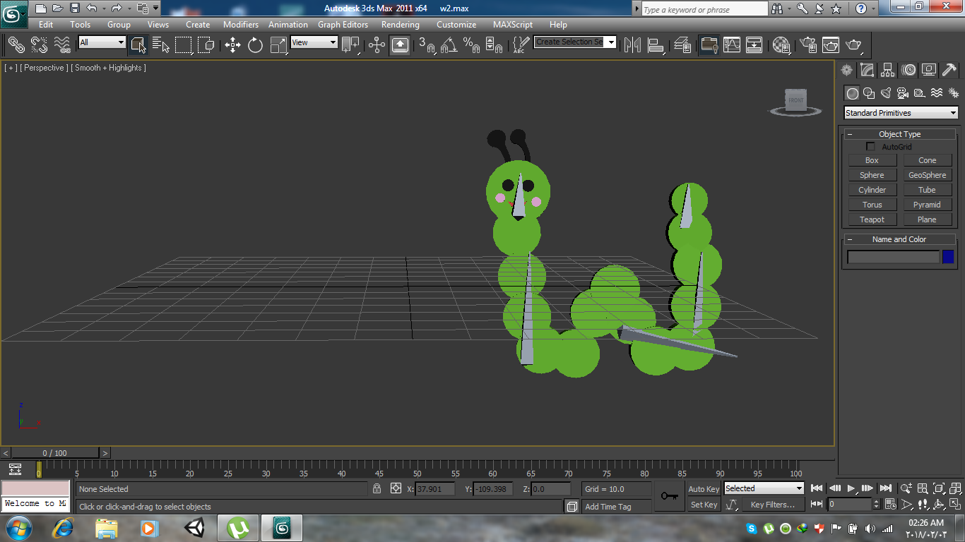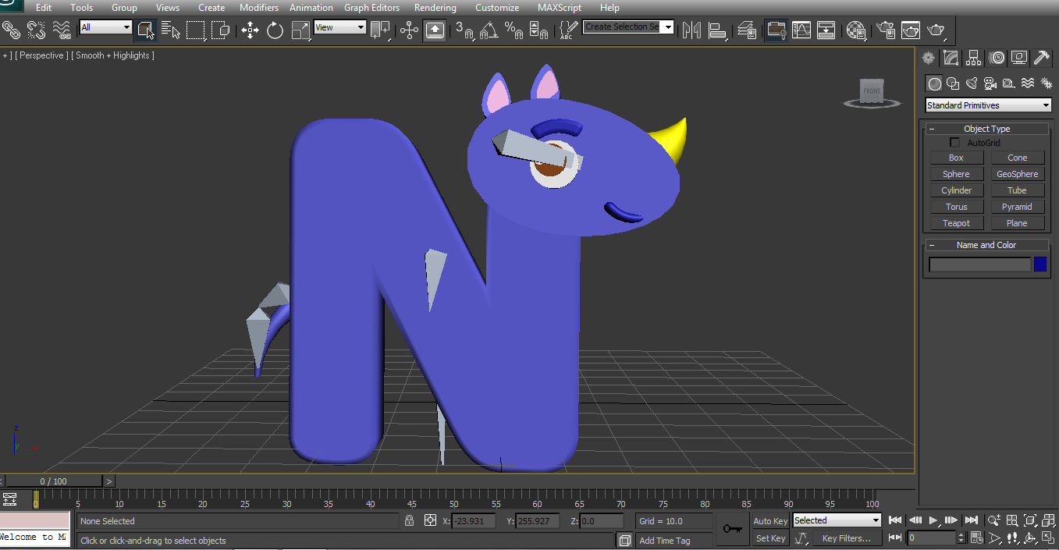

English letters

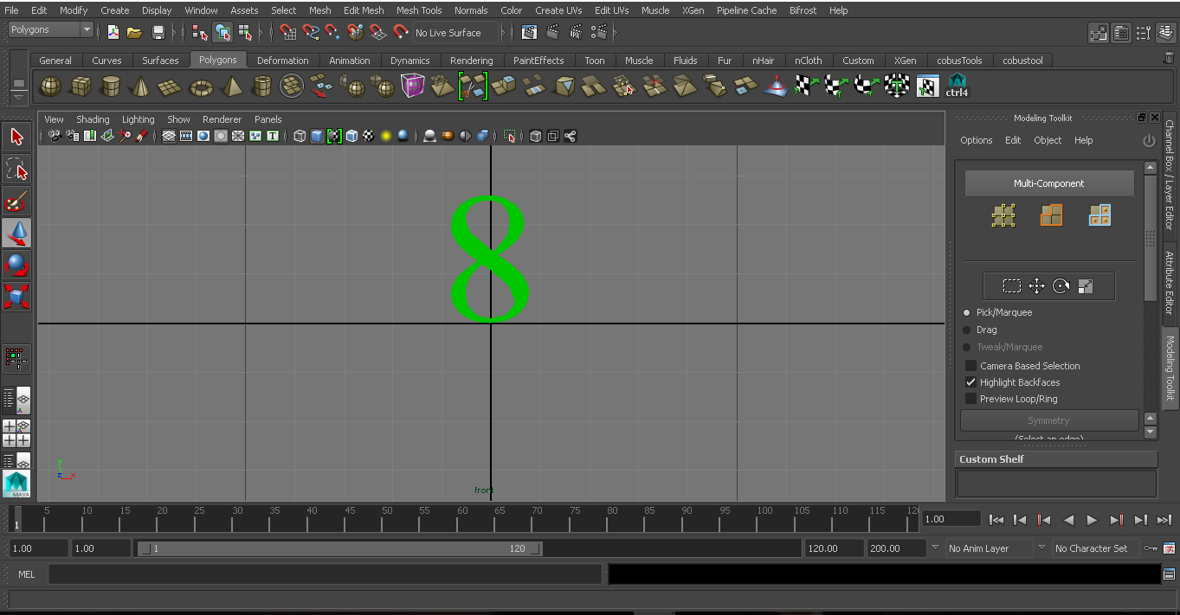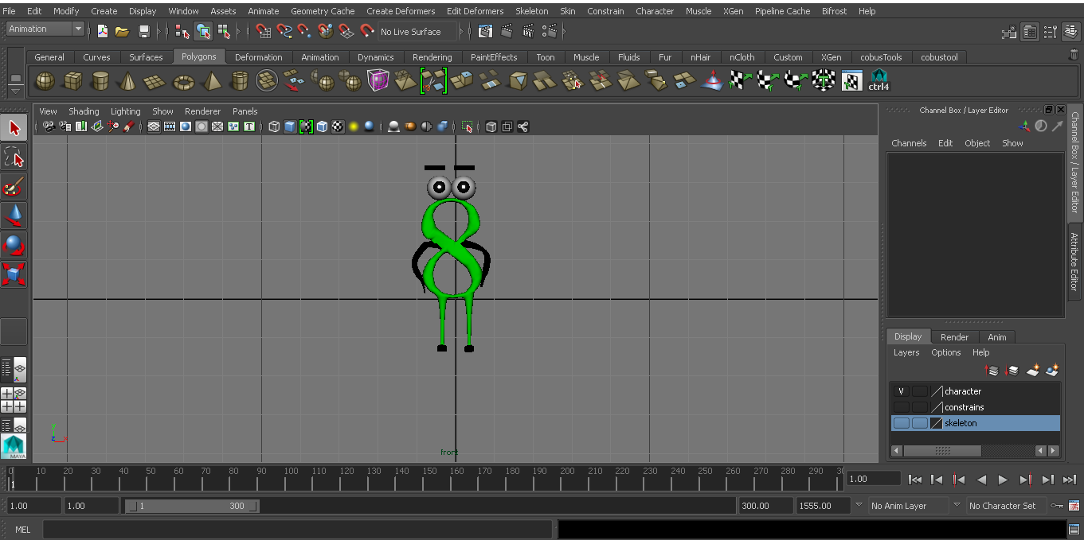

English number

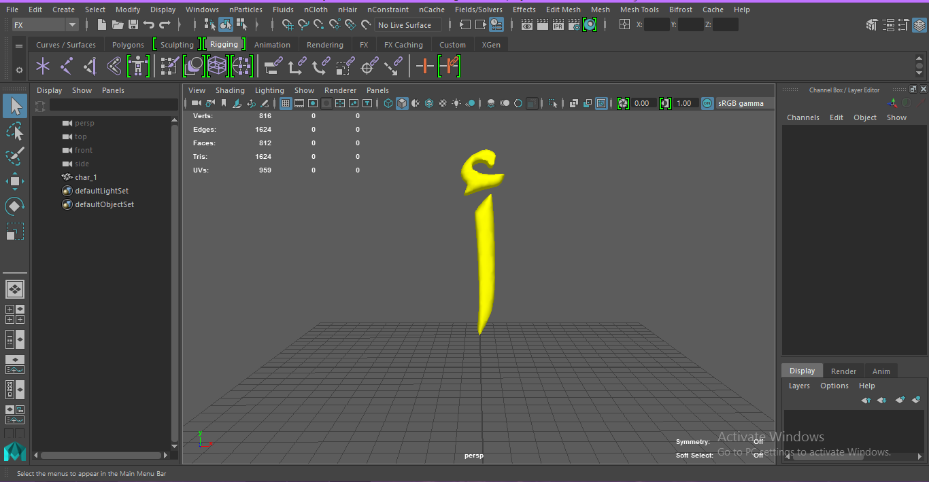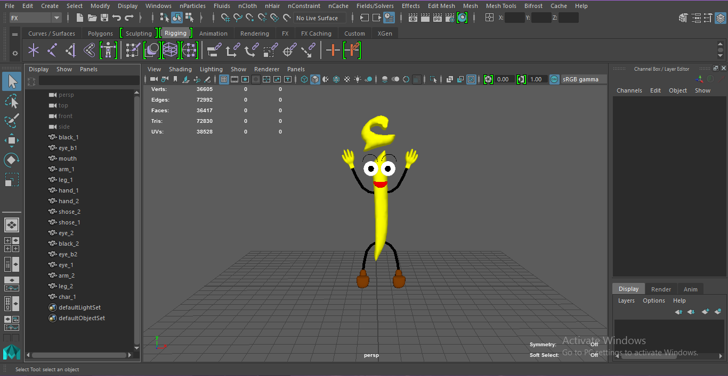

Arabic letters

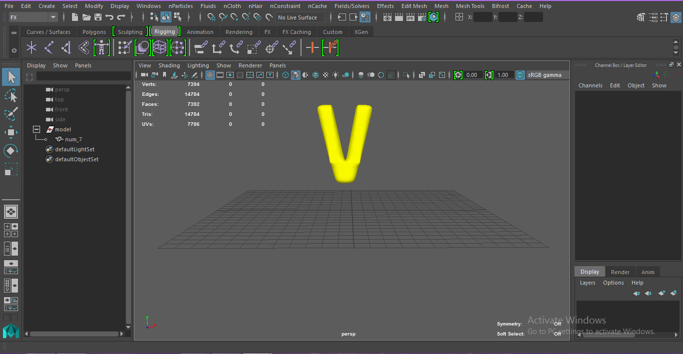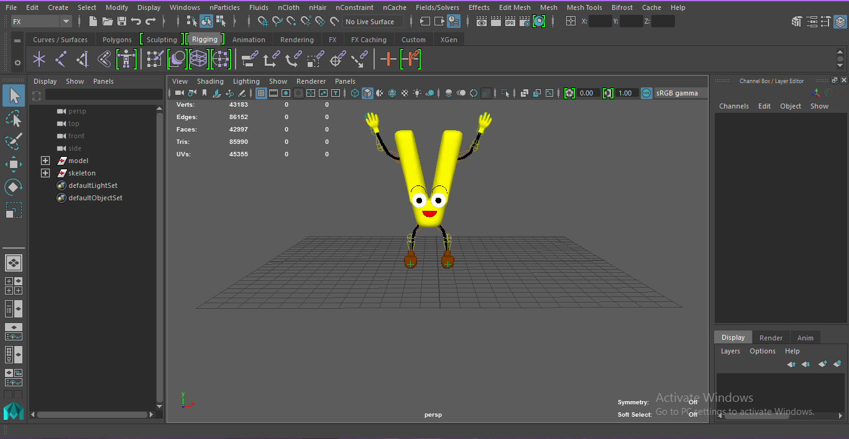

Arabic numbers

* Vuforia and targets

First we get license to be able to use vuforia in unity



License

After adding license to our project we start making image targets.



Image targets

* **Design** :-

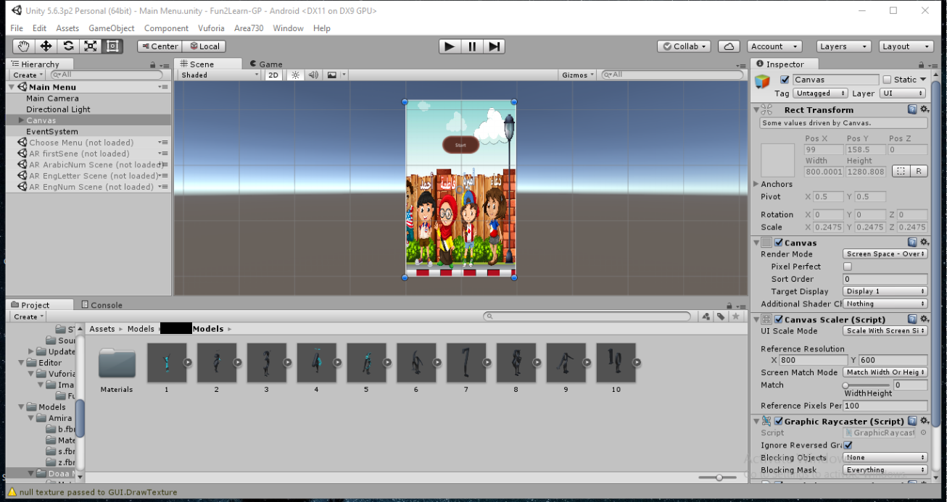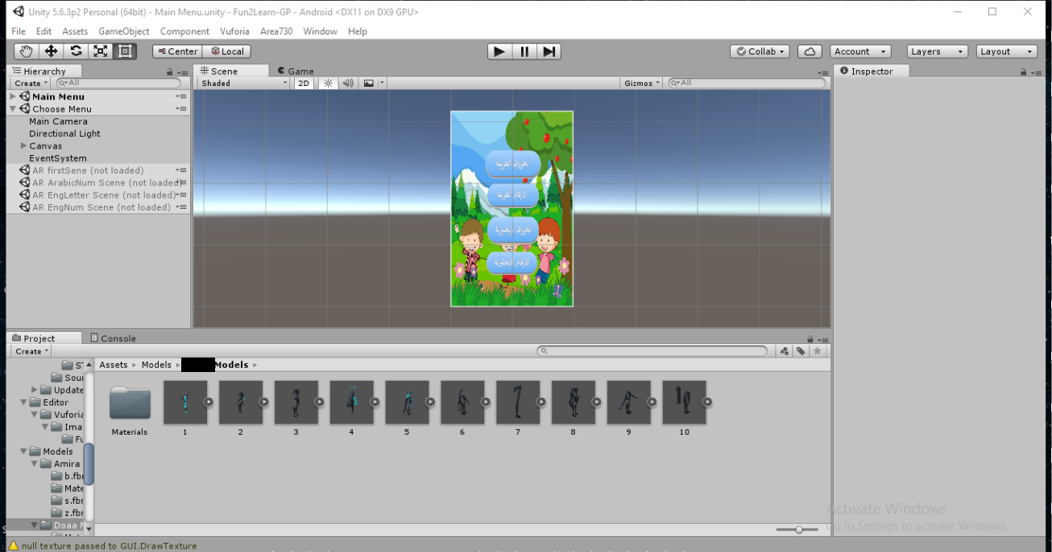

Start menu

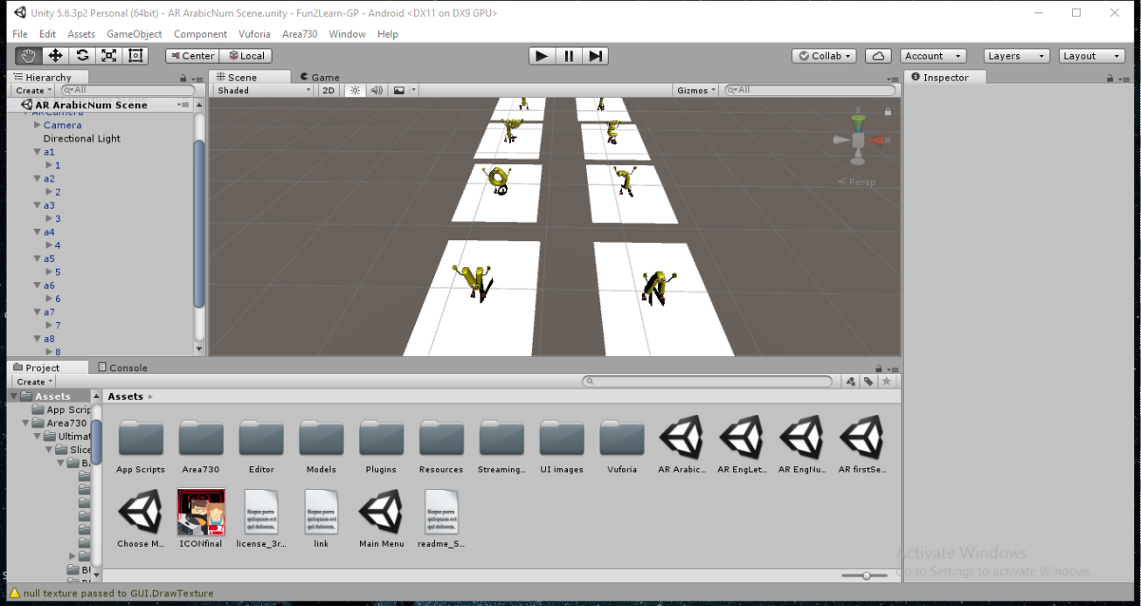

Arabic numbers scene

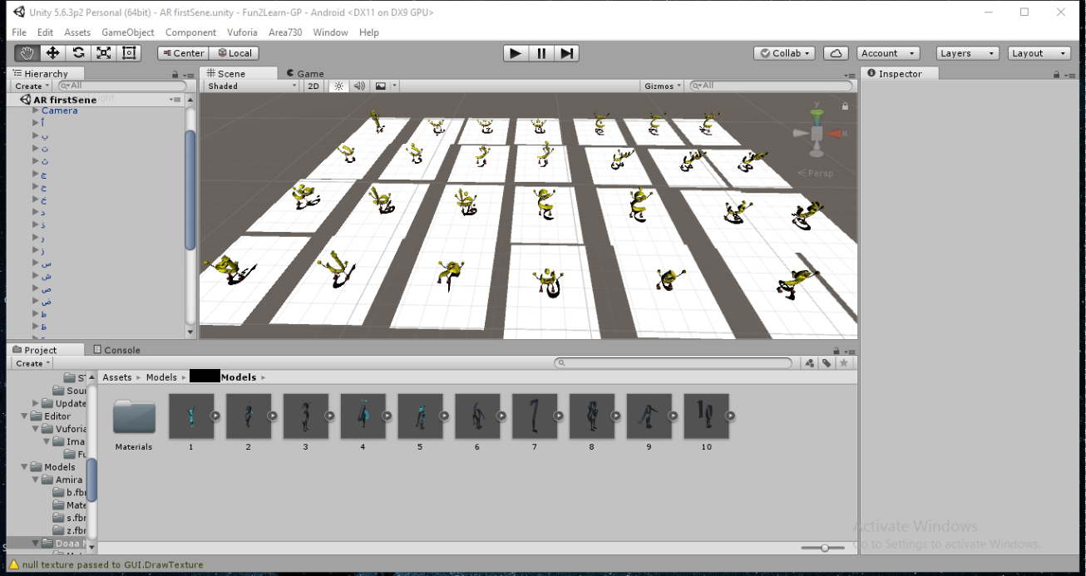

Arabic letters scene

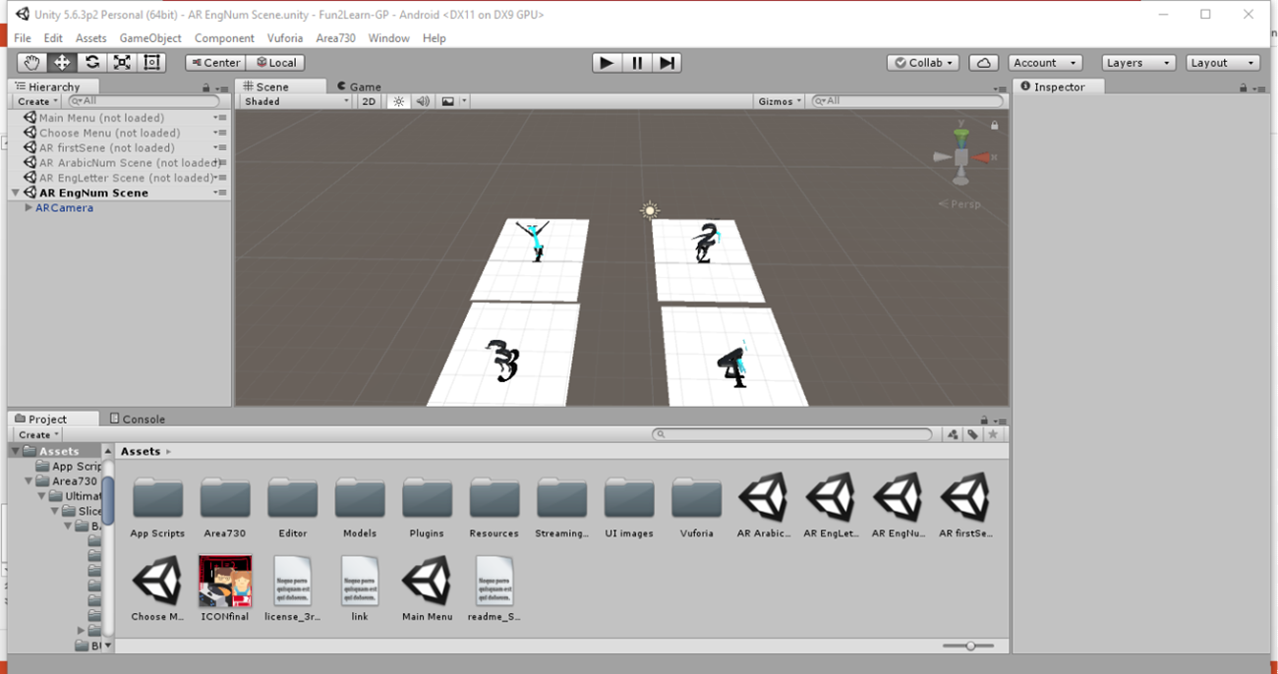

English numbers scene

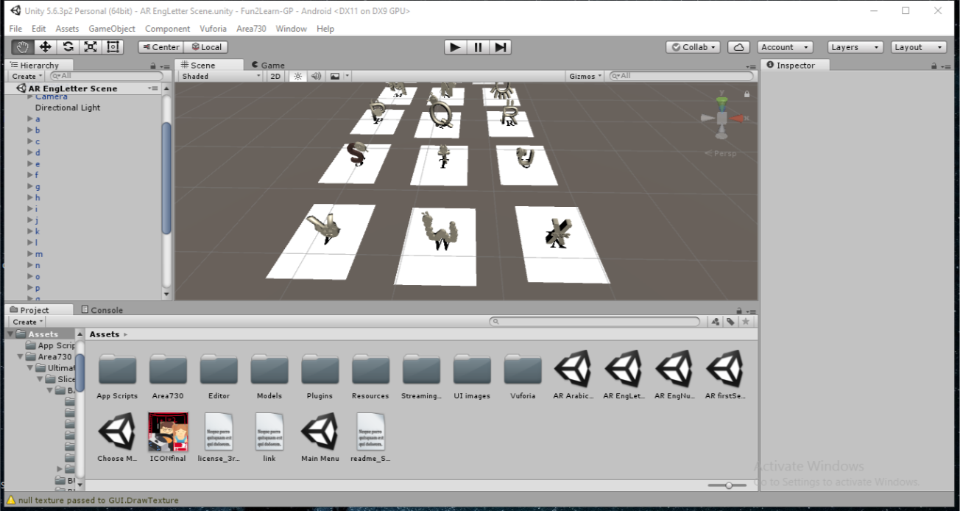

English letters scene

**7- Output :-**

Here's screen shots of the game running on Android device

